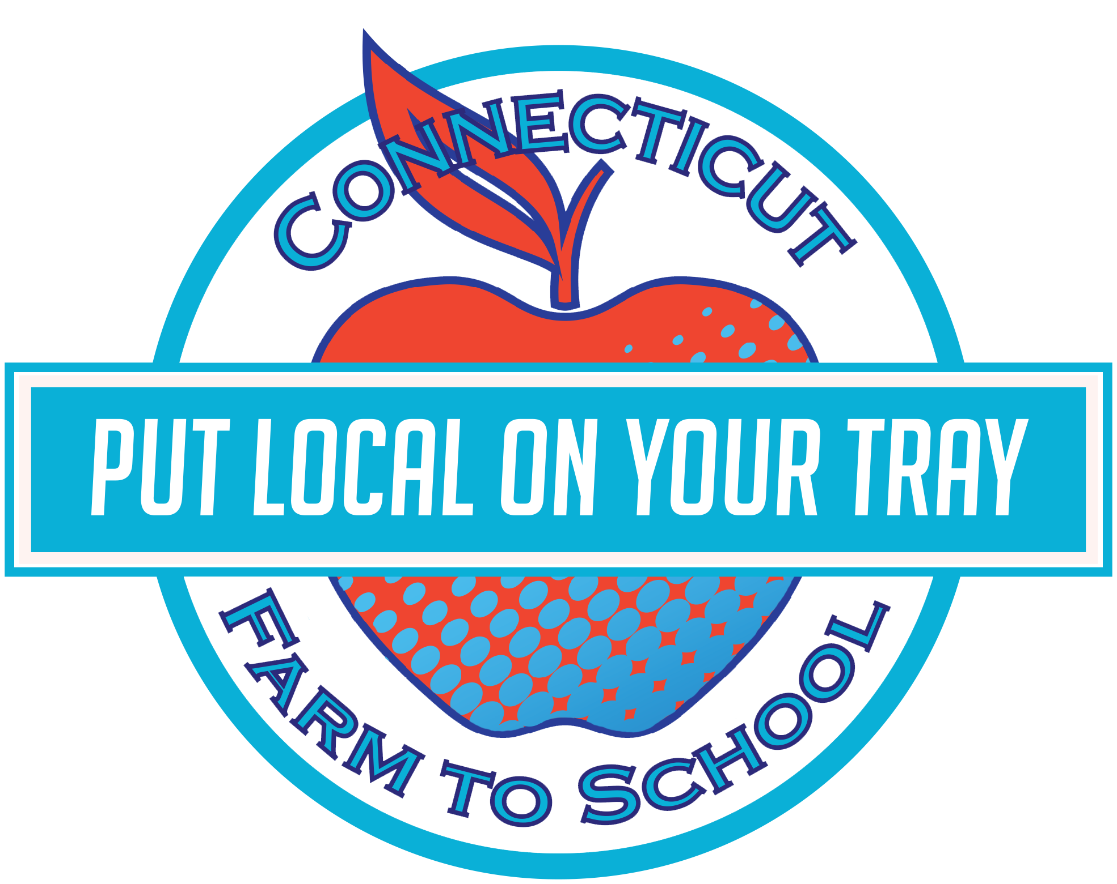

**Apples Before Houses**

Many of the first New England settlers planted appleorchards before they built theirhouses!

**Eat your fiber!**

Pears are one of the highest-fiber fruits – a medium fruit has about 6 grams of fiber.

This month our cafeteria is featuring local pears and apples! Staff will be preparing some fresh, local, pears on **Tuesday, October 7th**, and apples the following week! We included a **Pearfectly** fun recipe you can whip up at home with some local pears and apples of your own!

After tasting the recipes this month, students will get to vote on whether they TRIED IT (it wasn’t my favorite), LIKED IT (it was good), or LOVED IT (it was delicious).

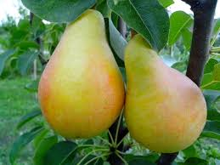

Tasty Tidbit:

Pears are great in desserts as well as in salads and are surprisingly tasty on pizza!

## Try something that PEARs up!!

This month Norris School

is celebrating local with:

Local Tray Day: Tuesday, October 7th

**OCTOBER**

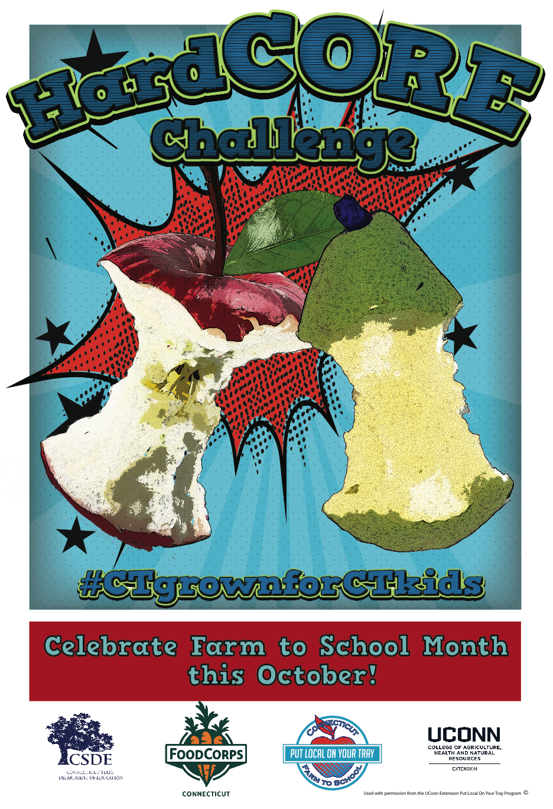

**Fun To Know**

Apples and Pears

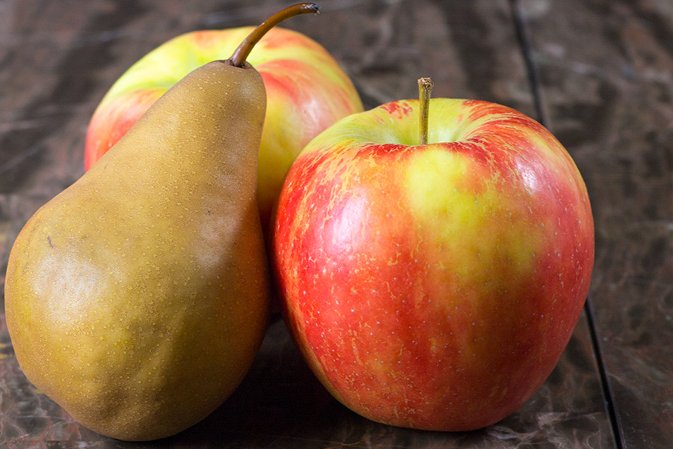

October: 2019

 

**Pear-y fun art! Apple-tastic!**

Gather pears BEFORE you try them and display them in the center of a room and see how you do at painting still-life with real fruit!

We just tasted some awesome pears – write a poem about how they tasted!

Take a guess – how many bites does it take to get to the CORE of your apple or pear. Draw Your Crunch with our coloring sheets (download from our website).

Taste test as many different types of pears and apples as you can find, and record how they are different!





**In the CLASSROOM**

Read *Are We Pears Yet?* by Miranda Paul

Or

*The Apple Pie Tree* by Zoe Hall

**Pear-applesauce**

Ingredients: 4 medium pears • 3 apples • 1/2 cup water • 1 teaspoon vanilla • ¼ teaspoon cinnamon

Wash pears and apples, core and slice each, combine with water and vanilla and cook, covered, in pan over medium heat for 10 minutes

Remove lid and cook for 10-15 more minutes, until most of the liquid is evaporated and fruit is softened

Cool, transfer to food processor, blend. Stir in cinnamon.

Serve warm or cold, use within 4 days.

Find a farm near you, pick up some produce, and have some fun! Not sure where to go? Visit **farmtocommunity.uconn.edu/** to find local products near you.

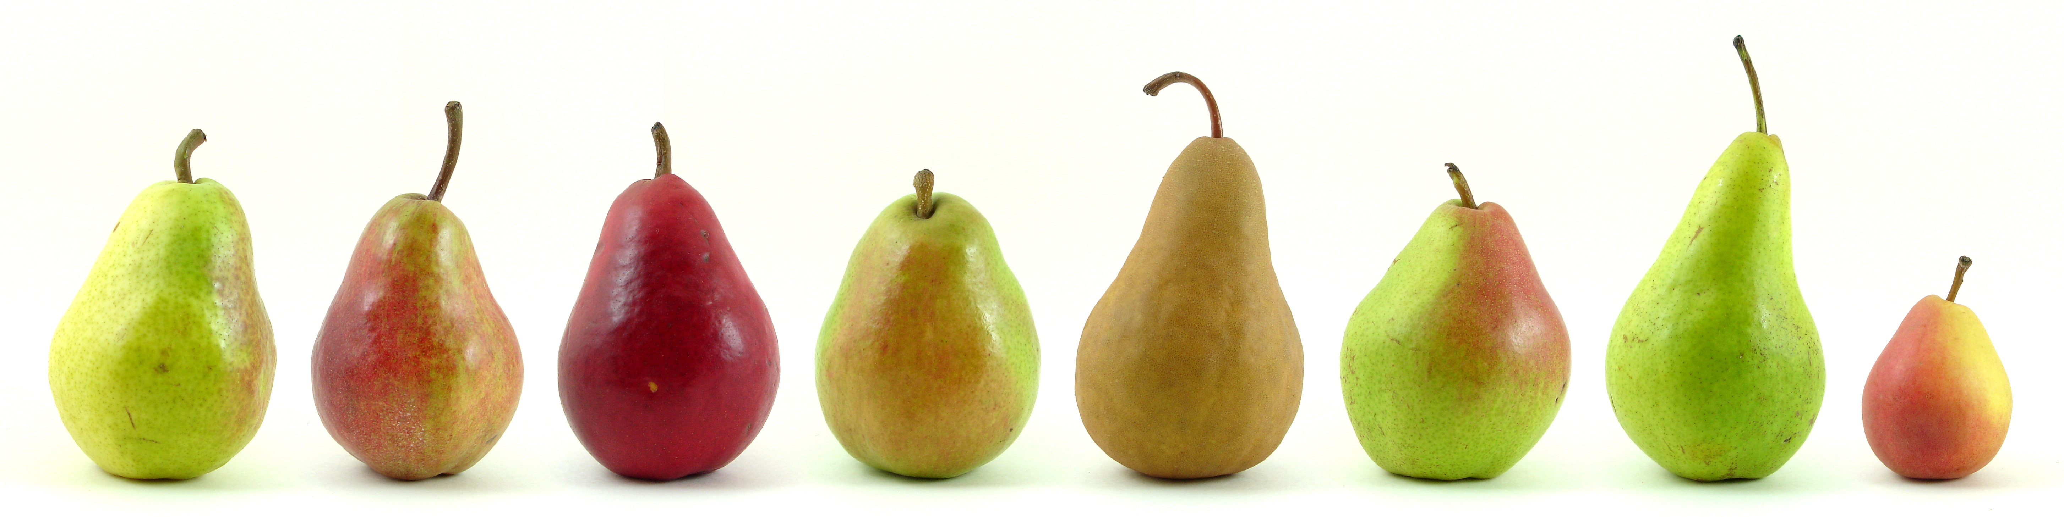

**Visit *Put Local On Your Tray* online!**

[**www.putlocalonyourtray.uconn.edu**](http://www.putlocalonyourtray.uconn.edu)

[**www.facebook.com/putlocalonyourtray**](http://www.facebook.com/putlocalonyourtray)

**Bring it**

**HOME**

### RECIPE

### ACTIVITY