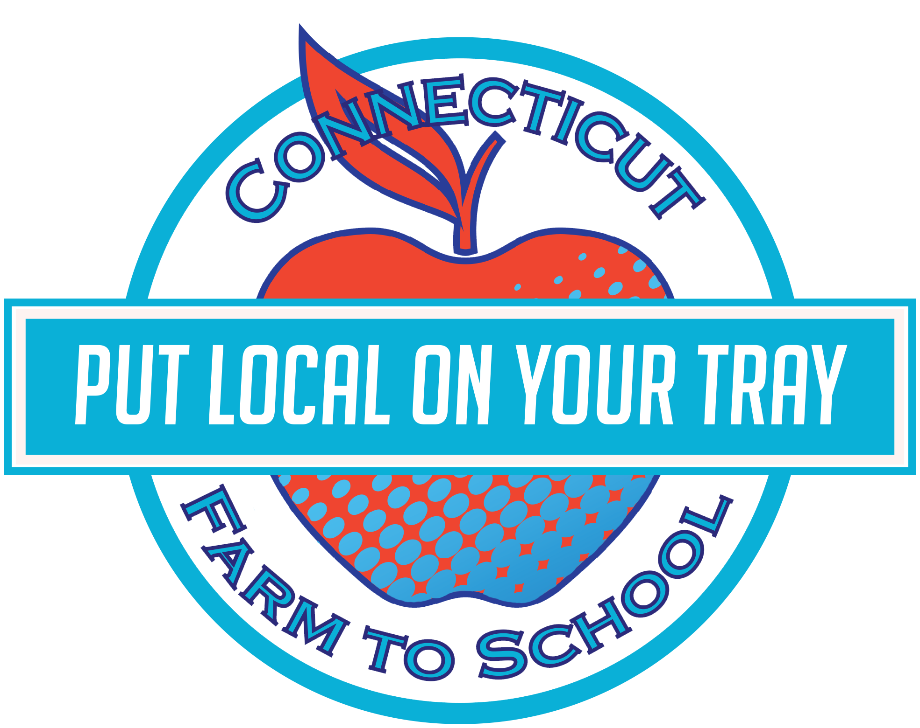

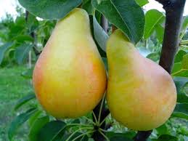

**Eat your fiber!**

Pears are one of the highest-fiber fruits – a medium fruit has about 6 grams of fiber.

Tasty Tidbit:

Pears are great in desserts as well as in salads and are surprisingly tasty on pizza!

**Love in the Trees!**

Pears grow on trees that have heart-shaped leaves.

## Try something that PEARs up!!

This month our summer meals program will feature local pears! Staff will be preparing some fresh, local, pears on **Tuesday, October 7th**. We included a **Pearfectly** fun recipe you can whip up at home with some local pears of your own!

After tasting the recipe, students will get to vote on whether they TRIED IT (it wasn’t my favorite), LIKED IT (it was good), or LOVED IT (it was delicious).

This month Norris School

is celebrating local with:

Local Tray Day: Tuesday, October 7th

**OCTOBER**

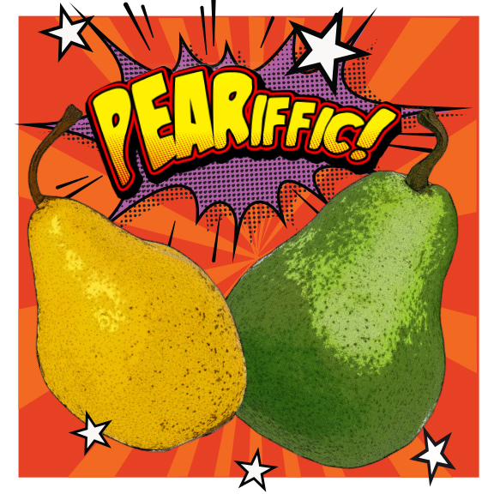

**Fun To Know**

Pears

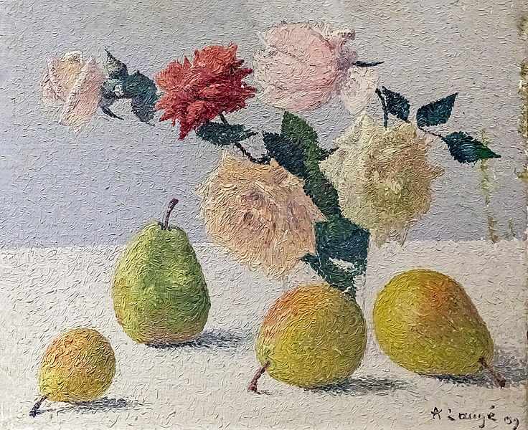

**Pear-y fun art!**

**In the CLASSROOM**

Read *Are We Pears Yet?* by Miranda Paul

October: 2019



Find a farm near you, pick up some produce, and have some fun! Not sure where to go? Visit **farmtocommunity.uconn.edu/** to find local products near you.

**Cinnamon Spiced Pears:**

Ingredients: 4 medium pears •1/4 C brown sugar • dash of Cinnamon • shake of Ginger • Canola Oil to coat •splash of orange juice

Wash pears, core and slice each into four equal pieces

Place pears in hotel pan and toss with orange juice. Add oil and evenly coat the pears. Add the brown sugar, cinnamon and ginger

Cover the pan tightly with foil and braise for 25 minutes at 350 degrees

Carefully remove pan from oven and toss the pears to evenly coat with the syrup that has formed.

Serve hot or cold. Recommended with: tossed salad of greens, raisins and sunflower seeds

Gather pears BEFORE you try them and display them in the center of a room and see how you do at painting still-life with real fruit!

We just tasted some awesome pears – write a poem about how they tasted!

Go Think about what a pair of pears might do on an adventure and write a pear story or draw a comic strip!

Taste test as many different types of pears as you can find, and record how they are different!





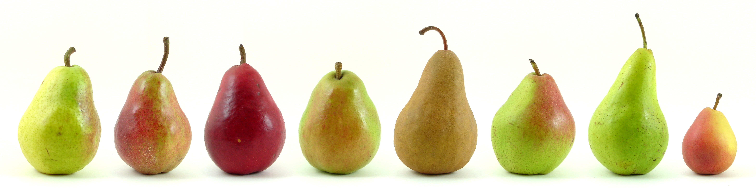

**Visit *Put Local On Your Tray* online!**

[**www.putlocalonyourtray.uconn.edu**](http://www.putlocalonyourtray.uconn.edu)

[**www.facebook.com/putlocalonyourtray**](http://www.facebook.com/putlocalonyourtray)

**Bring it**

**HOME**

### RECIPE

### ACTIVITY