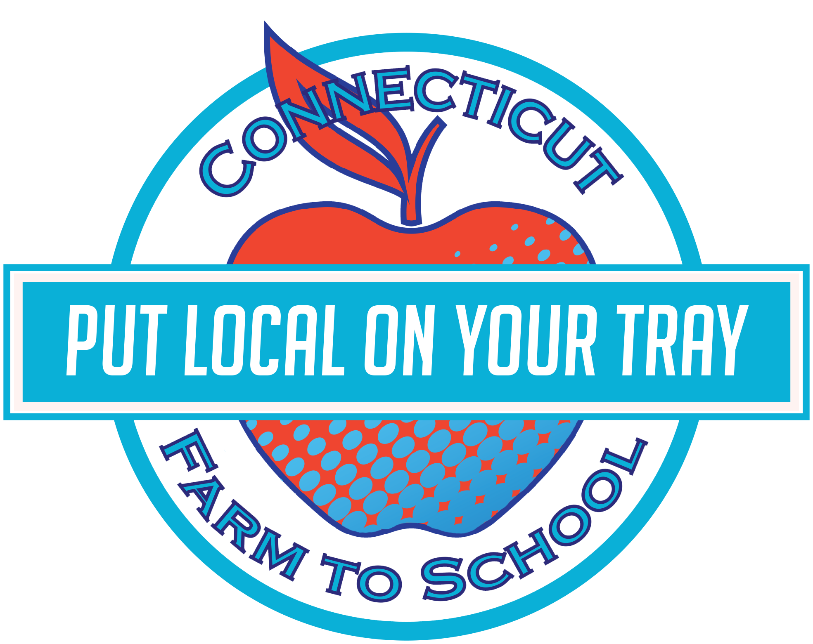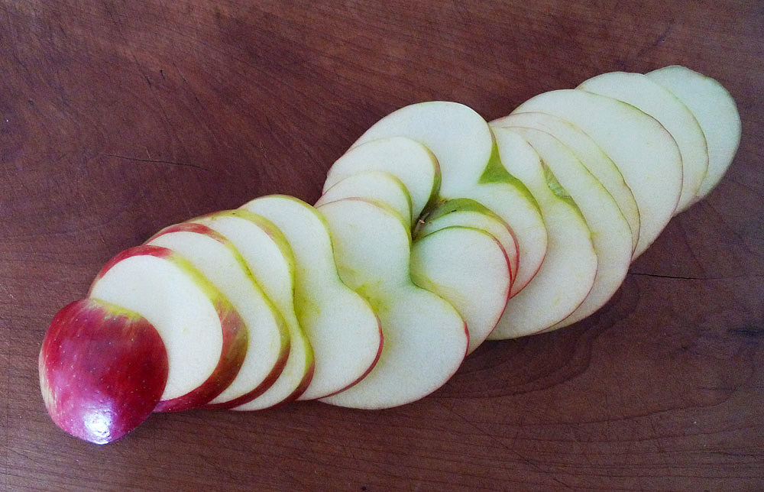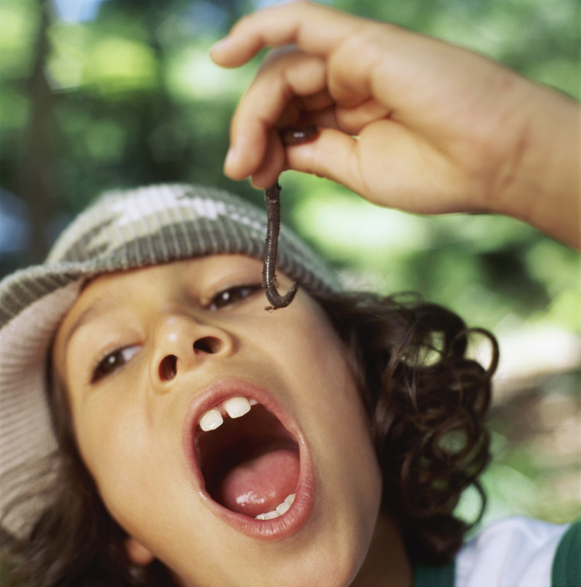

Tasty Tidbit #1:

Studies show that kids may need to try a new fruit or vegetable 7 times or more before their palates adjust and a preference develops. Keep calm and taste on!

This month John Winthrop Middle school

is celebrating

Local Tray Day: Thursday, October 29 12

This month our cafeteria is featuring local apples from Scotts’ Orchard behind the high school! Food Service staff are getting ready to prepare some delicious samples with these fresh apples.

On **Thursday, October 29th** students will have a chance to sample these local apple dishes at a tasting station in the cafeteria. We’ll be voting on what we like, and we’ll see the things we love on the lunch menu the following Friday! We will be featuring and tasting a different local product each month this year through our Put Local On Your Tray project.

## Get your taste buds ready!

**There are 2500 kinds of apples grown in the United States. How many can you name?**

Macintosh, Pink Lady, Red Delicious, Granny Smith…

Apples

OCTOBER

**Apples Before Houses:**

Many of the first European settlers in New England planted apple orchards before they built their houses!

**Fun To Know**

October : 2015

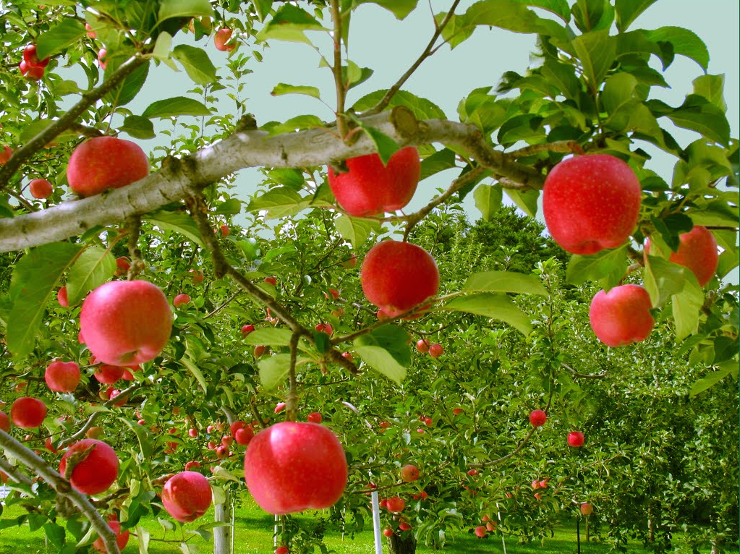 

**Peanut Butter Apple Wrap:**

Ingredients: whole-wheat tortillas (6-inch) • peanut butter (or sunflower butter) • diced apples •

Spread 2 Tablespoons of peanut butter on the tortilla.

Dice apple, and sprinkle ½ cup over the tortilla.

Roll up tortilla, cut diagonally in half.

Enjoy!

**Apple Taste Test:**

Find a farm or farmstand and purchase several different apple varieties

Visit your usual supermarket and select a few other apples

Cut a few slices from each apple, making sure to remember which apple the slices belong to.

Choose your first slice, close your eyes and smell; note any aromas. Now put the slice on your tongue without chewing. What flavors do you detect? Now slowly chew and swallow. Record your observations and repeat. Compare each variety!



### RECIPE

### ACTIVITY

**Find a farm near you, pick up some produce, and have some fun! Not sure where to go? Visit buyctgrown.com to find local products near you.**

Bring it

HOME

**Visit *Put Local On Your Tray* online!**

[**www.putlocalonyourtray.uconn.edu**](http://www.putlocalonyourtray.uconn.edu)

[**www.facebook.com/putlocalonyourtray**](http://www.facebook.com/putlocalonyourtray)