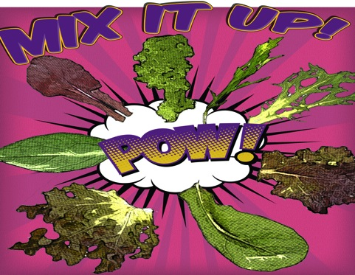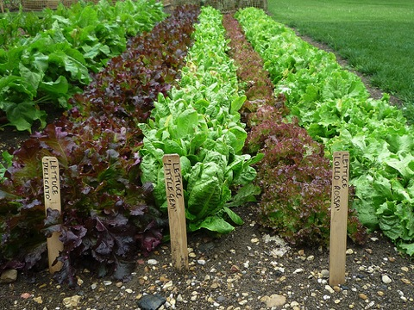

**Salad Rocket!**

Arugula has thin hairy stems, and is therefore named after the Latin word *Eruca*, which means caterpillar- a hairy little insect!

**Iron powerhouses!**

Spinach contains more iron by weight than a hamburger! Iron is important for energy because your body needs it to make oxygen carrying red blood cells!

**Fun To Know**

This month Spencer School

is celebrating local with:

Tasty Tidbit:

Vegetables don’t always have to be put in a salad- they can be blended in a smoothie or juiced with some fruits for a fresh drink in warmer months.

Local Tray Day: Thursday, May 19th

This month our cafeteria will feature local salad greens! Staff will be whipping up some Green Goddess Juice for students at Spencer School, on **Thursday, May 19th**. Check out the recipe later on in the newsletter!

After tasting the recipe, students will get to vote on whether they TRIED IT (it wasn’t my favorite), LIKED IT (it was good), or LOVED IT (it was delicious).  
   
RESULTS:

Tried it: 62

Liked it: 75

Loved it: 134

## Go green for May!

Greens

**MAY**

**In the**

**CLASSROOM**

Read *Lettuce!* by Diana Kizlauskas to learn about values, sharing, and this popular green veggie!

May: 2016



**Greens Taste Test:**

Find a farm or farmstand and purchase several different varieties of greens (try mustard greens, collards, kale, spinach!)

Visit your usual supermarket and select a few other greens (lettuce, arugula, etc.)

Wash the greens and place them on different plates.

Choose your first leafy green, close your eyes and smell; note any aromas. Now taste the leaf. Open your eyes and note the color and shape. Write down what you taste, smell, How many different colors of salad “greens” did you find (HINT: some can be purple!)?



Find a farm near you, pick up some produce, and have some fun! Not sure where to go? Visit buyctgrown.com to find local products near you.

**Bring it**

**HOME**

**Green Goddess Juice:**

Ingredients: 8 leafy greens • ½ a cucumber • 1 ch □  parsley • ½ a pineapple • 2 green apples

Wash kale, parsley, cucumber, apples.

Chop and peel the pineapple.

Add all ingredients to a juicer.

Pour into a cup and ENJOY!

### RECIPE

### ACTIVITY

**Visit *Put Local On Your Tray* online!**

[www.putlocalonyourtray.uconn.edu](http://www.putlocalonyourtray.uconn.edu)