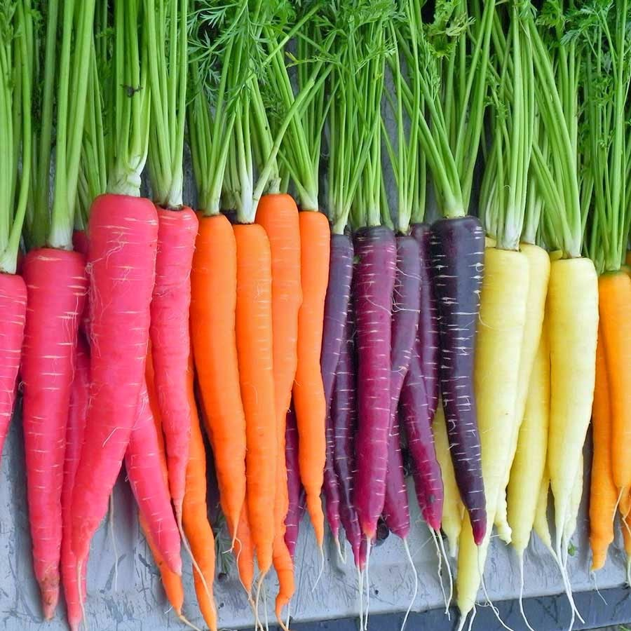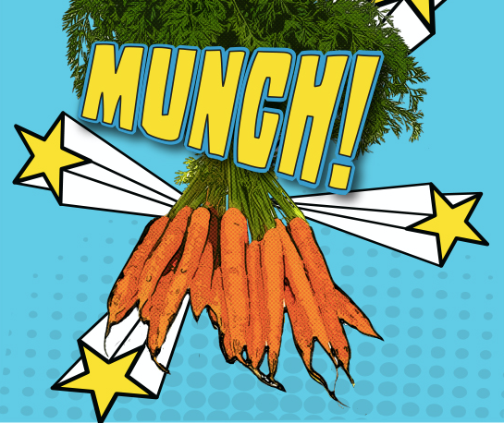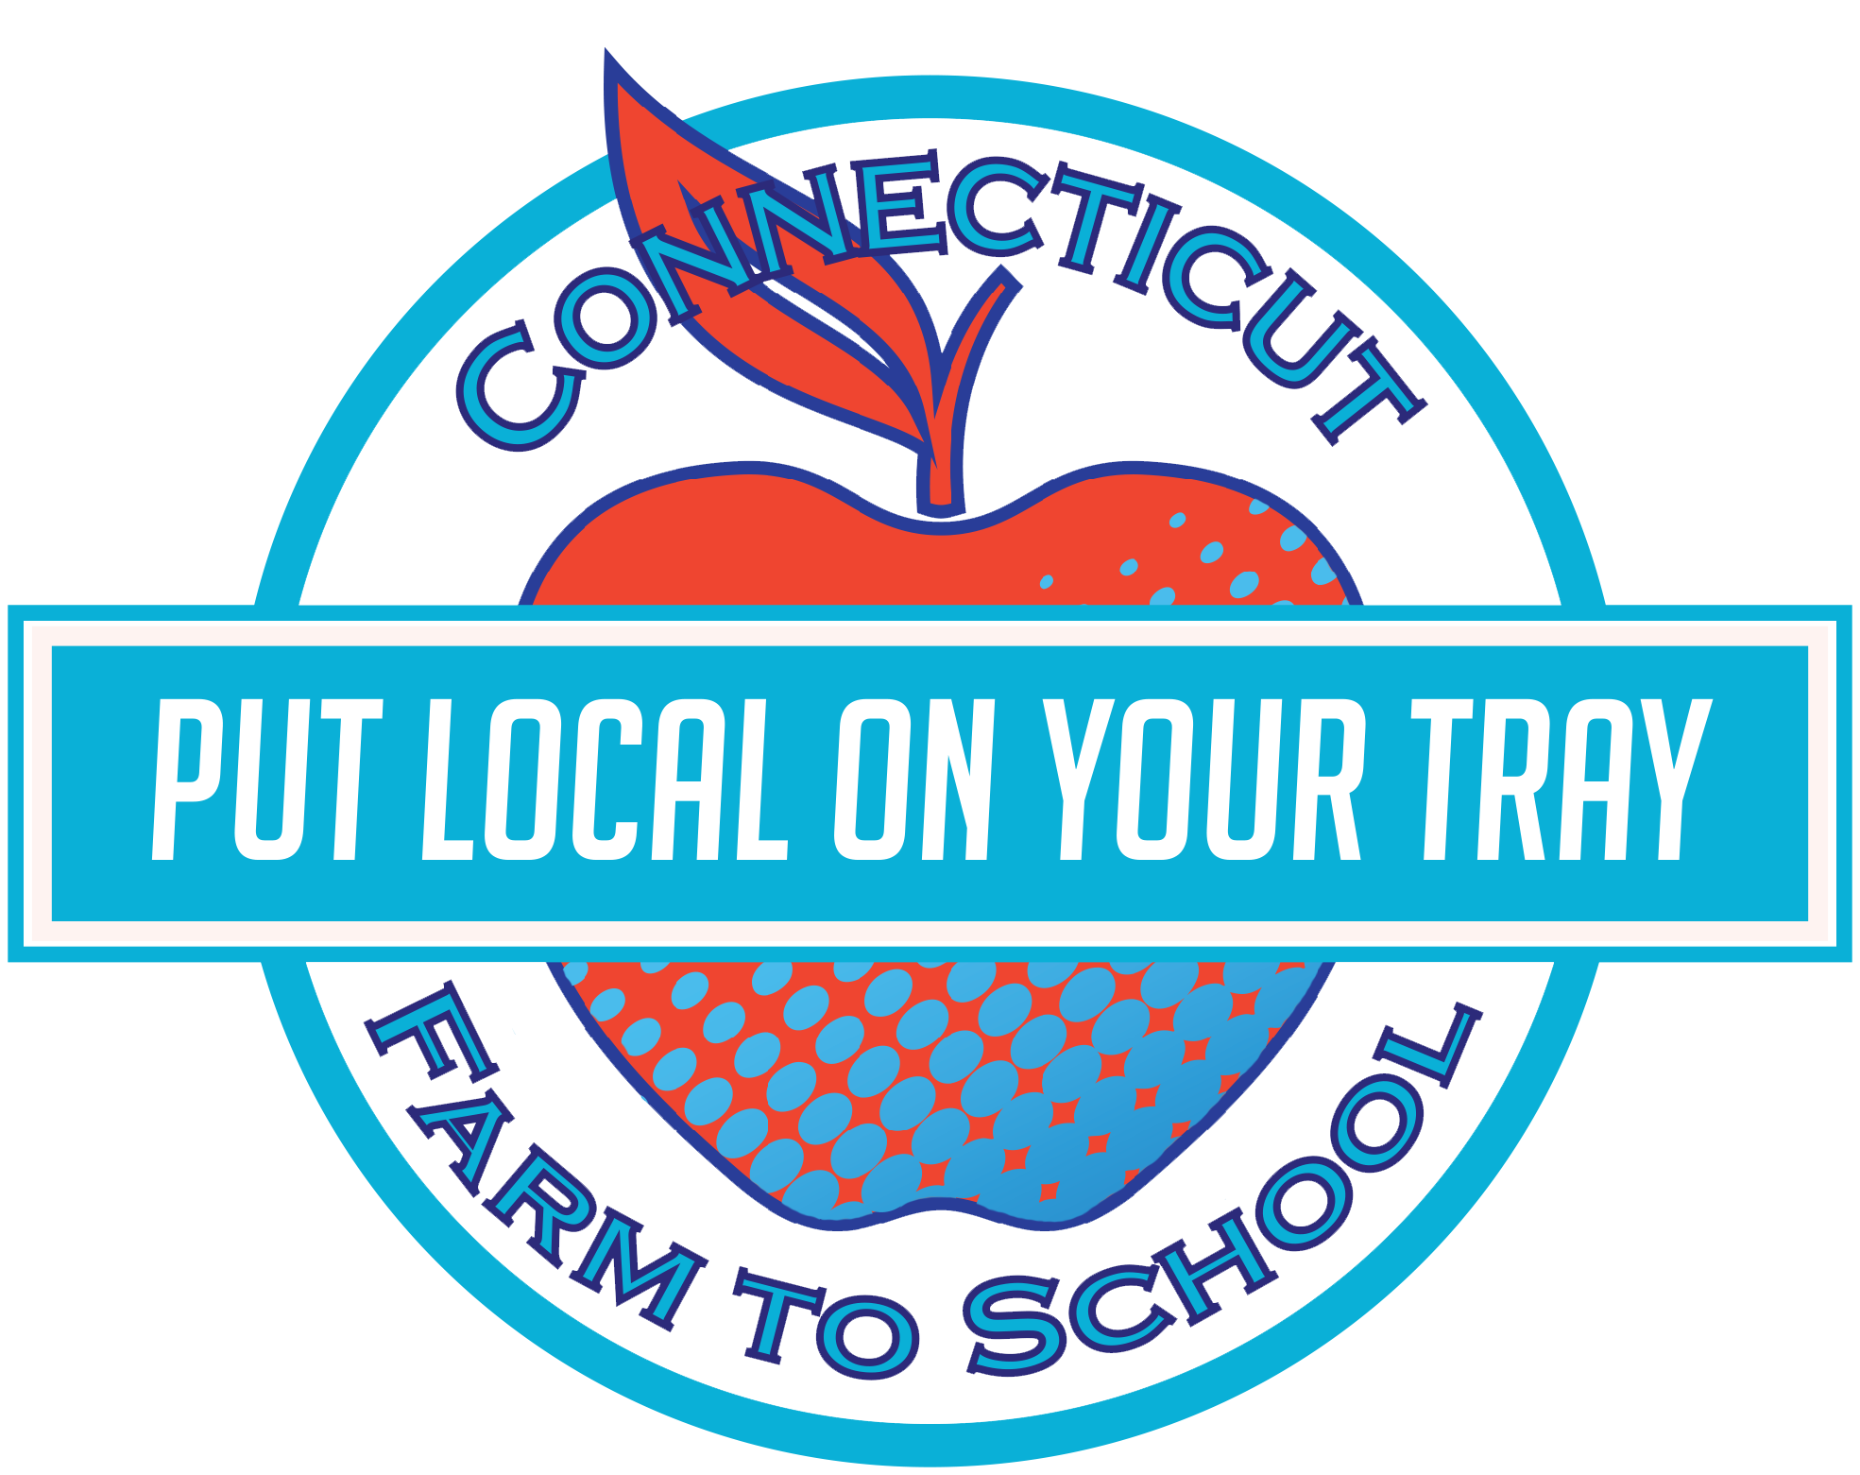 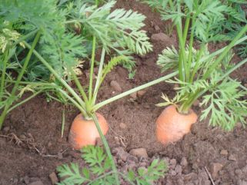

**Medicine First**

Carrots were first cultivated for their medicinal qualities, before they became a common vegetable

**Fun to Know**

Tasty Tidbit:

It’s a myth that carrot greens are poisonous! They can be eaten cooked, or used raw in a salad. They make an excellent pesto in place of basil leaves as well!

Local Tray Day

Thursday, January 7th

Carrots

This month our summer meals program will feature local __________! Staff will be preparing some fresh, local, __________on **Thursday, January 7th**. In this newsletter you will find a fun recipe you can whip up at home with some local _____ of your own!

After tasting the recipe, students will get to vote on whether they TRIED IT (it wasn’t my favorite), LIKED IT (it was good), or LOVED IT (it was delicious).

**Crazy Colors**

When carrots were first cultivated around 900AD, there were no orange carrots, only yellow and purple!

This month ____ School

is celebrating local with:

**JANUARY**

## Crunchy Carrot Craziness!

**Simple Oven Roasted Carrots**

Ingredients: 12 Carrots • 3 Tbsp Olive Oil • 1.25 tsp Salt • 1/2 tsp Pepper • 2 TBSP freshly minced dill and parsley

Wash and cut carrots into 2 inch pieces, slicing diagonally

Toss in a bowl with olive oil, salt and pepper

Spread carrots on a baking sheet

Bake at 400o F for 20 minutes, or until lightly browned and tender.

Garnish with parsley and dill

**Germination Observation:**

G Gather a clear glass jar, a roll of paper towels, and some seeds.

Wet the paper towels one at a time and stuff them into the jar.

Pick 3 or 4 seeds and place them inside between the side of the jar and the paper towels (make sure you can see them!)

If you used different kinds of seeds, make sure to label the jar on the outside so you can keep track

Keep the paper towels moist (but not soaking) for the next week or so. Make sure to check the jar every day to see what the seeds are up to!





January: 2017



**In the CLASSROOM**

Read: *The Carrot Seed*, by Ruth Krauss

**Visit *Put Local On Your Tray* online!**

[**www.putlocalonyourtray.uconn.edu**](http://www.putlocalonyourtray.uconn.edu)

[**www.facebook.com/putlocalonyourtray**](http://www.facebook.com/putlocalonyourtray)

Find a farm near you, pick up some produce, and have some fun! Not sure where to go? Visit buyctgrown.com to find local products near you.

**Bring it**

**HOME**

### RECIPE

### ACTIVITY