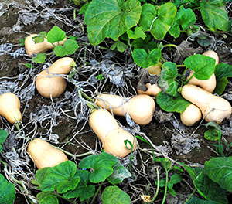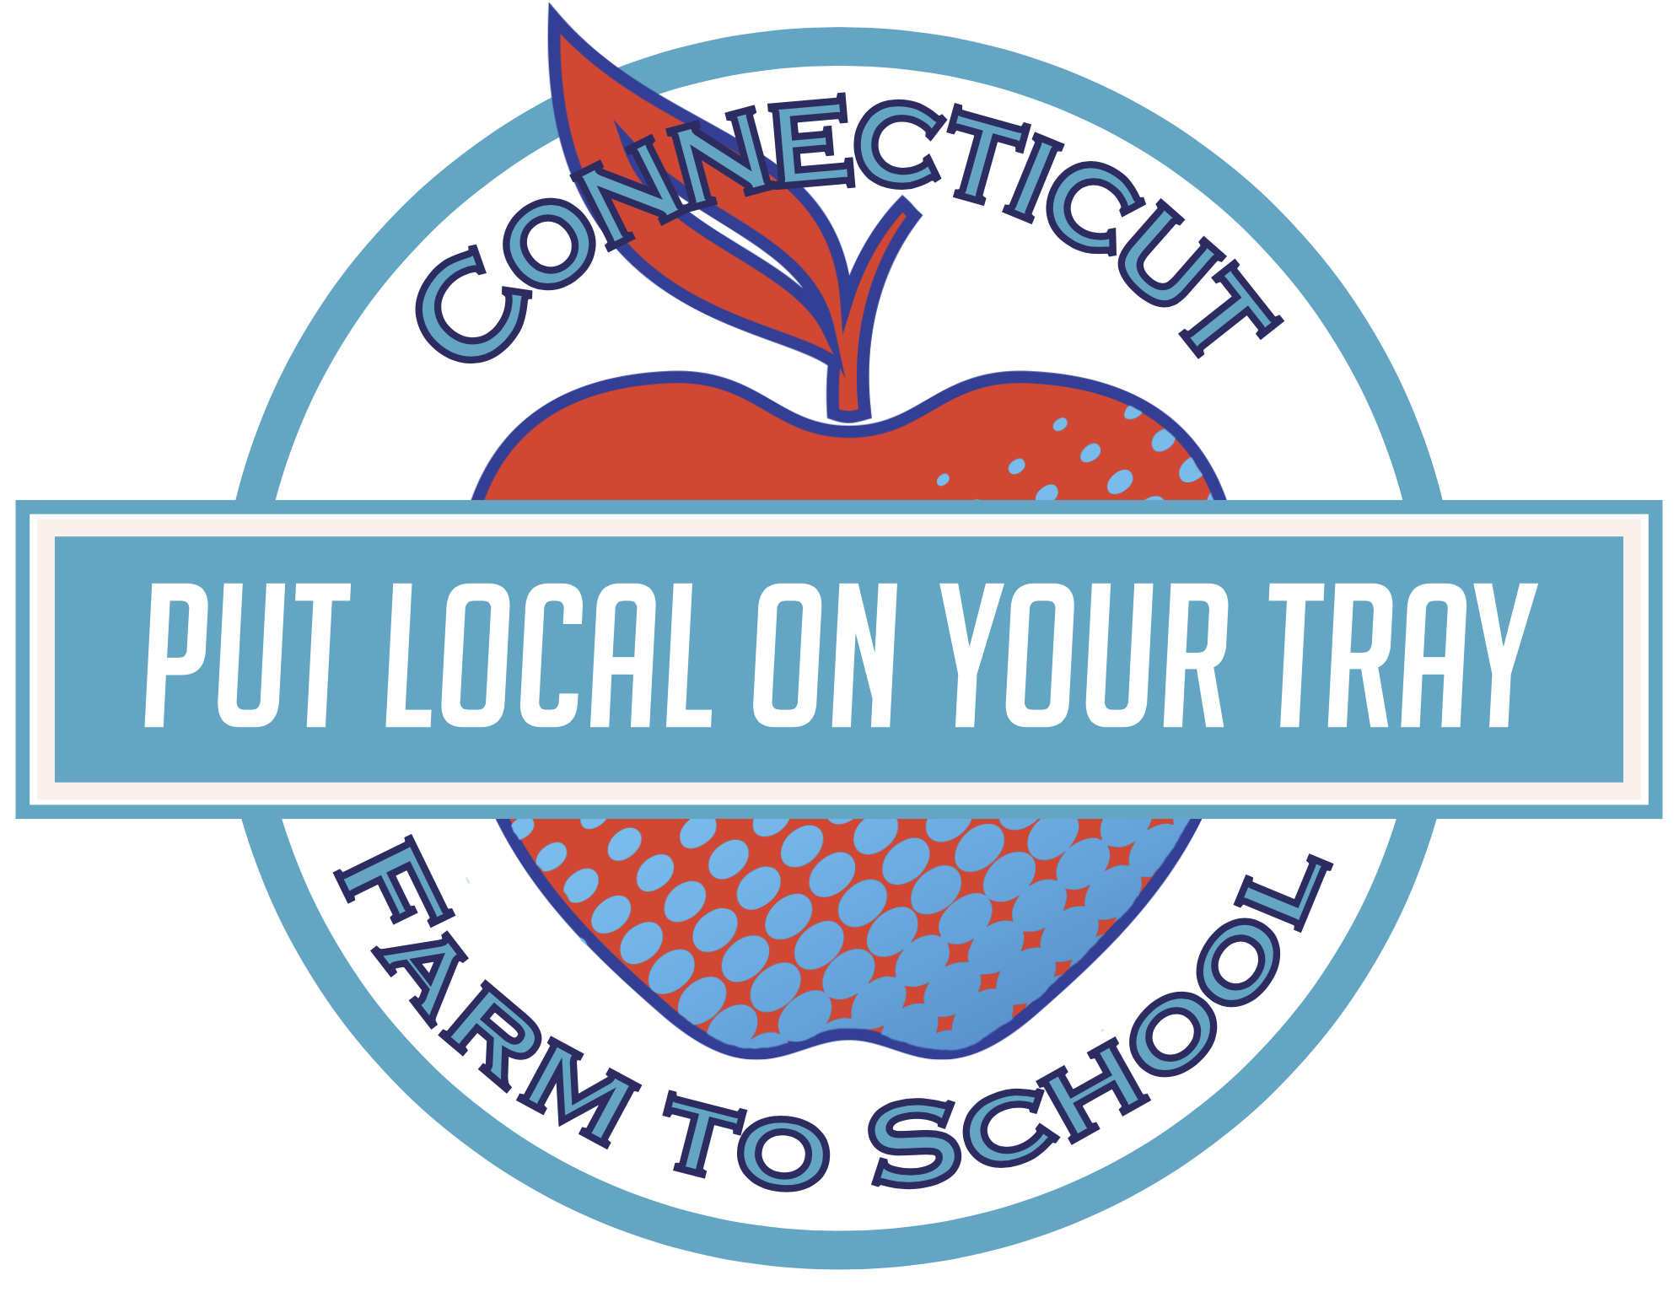 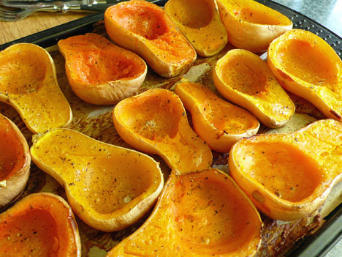

This month our cafeteria is featuring local Butternut Squash from **GALENSKI FARM in South Deerfield Massachusetts!**

On Tuesday December 15th, students will have a chance to sample cider-glazed butternut squash (see next page for the recipe!). They will vote on whether they: Tried It (it wasn’t my favorite), Liked It (it was pretty good), or Loved It (it was delicious!).

Butternut squash is one of the most popular winter squash varieties. It grows on a vine and does very well in storage, which is why we can still eat local squash in December!

Tasty Tidbit #2:

Butternut squash can be roasted and mashed with butter, salt, and pepper just like regular or sweet potatoes. Yum!

## Get your taste buds ready!

Butternut

Squash

This month **Sunset Elementary School**

is celebrating local

**Eat the seeds!**

Did you know that squash seeds are edible? They are rich in protein, fiber, and many heart-healthy vitamins and minerals. Roast some in the oven with a little oil and salt!

2

**Fun To Know:**

**A sister of three**

Squash was a staple food for Native American tribes in New England. Because it was traditionally grown with beans and corn, squash is one of the “three sister” crops.

LOCAL TRAY DAY

Tuesday, December 15th

DECEMBER

December : 2015



**How Many Seeds?**

Take a guess at how many seeds are inside one Butternut Squash

Next, get a Butternut (or some other kind of squash) from a local farm stand or grocery store.

Cut the squash open lengthwise with a knife.

Scoop out the gooey strands and seeds.

Spread everything out on a doubled layer of newspaper and let dry overnight.

Once the squash innards are dry, separate the seeds and count them. How close were you to your original guess?



Separate the seeds and count how many there are. How close did you get?



**Cider-Glazed Butternut Squash**

Ingredients: 1 Butternut Squash • 2 Tbsp Butter or Oil • ¾ Cup Apple Cider • ¼ Cup Apple Cider Vinegar • 2 Tbsp Brown Sugar • Salt • Pepper

Combine cider, cider vinegar, and brown sugar in a saucepan. Bring to a boil, then simmer until it thickens to syrup consistency (this may take a while!)

Peel and cut squash into 1-inch cubes. Coat with butter/oil, salt and pepper. Roast for about 15 minutes at 400 degrees.

Remove squash from oven and cover with cider glaze. Bake 5 more minutes until evenly browned.

**Find a farm near you, pick up some produce, and have some fun! Not sure where to go? Visit buyctgrown.com to find local products close to home.**

### RECIPE

### ACTIVITY

Bring it

HOME

**Visit *Put Local On Your Tray* online!**

[**www.putlocalonyourtray.uconn.edu**](http://www.putlocalonyourtray.uconn.edu)

[**www.facebook.com/putlocalonyourtray**](http://www.facebook.com/putlocalonyourtray)