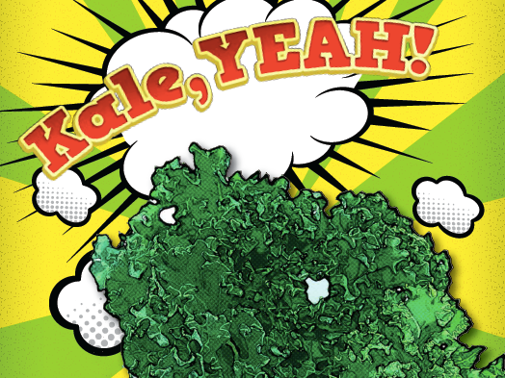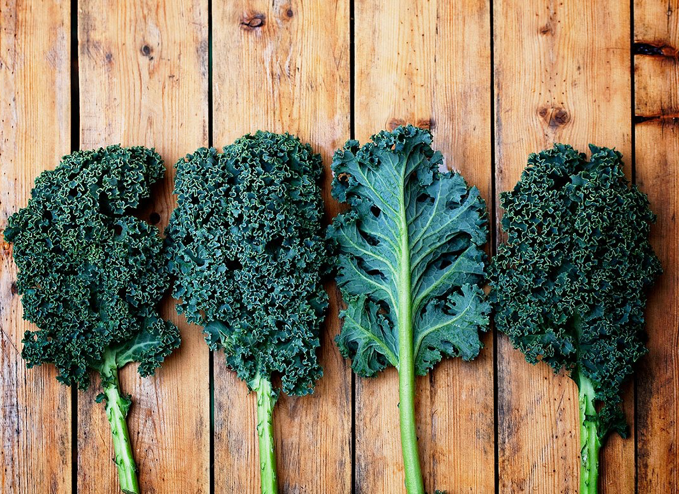 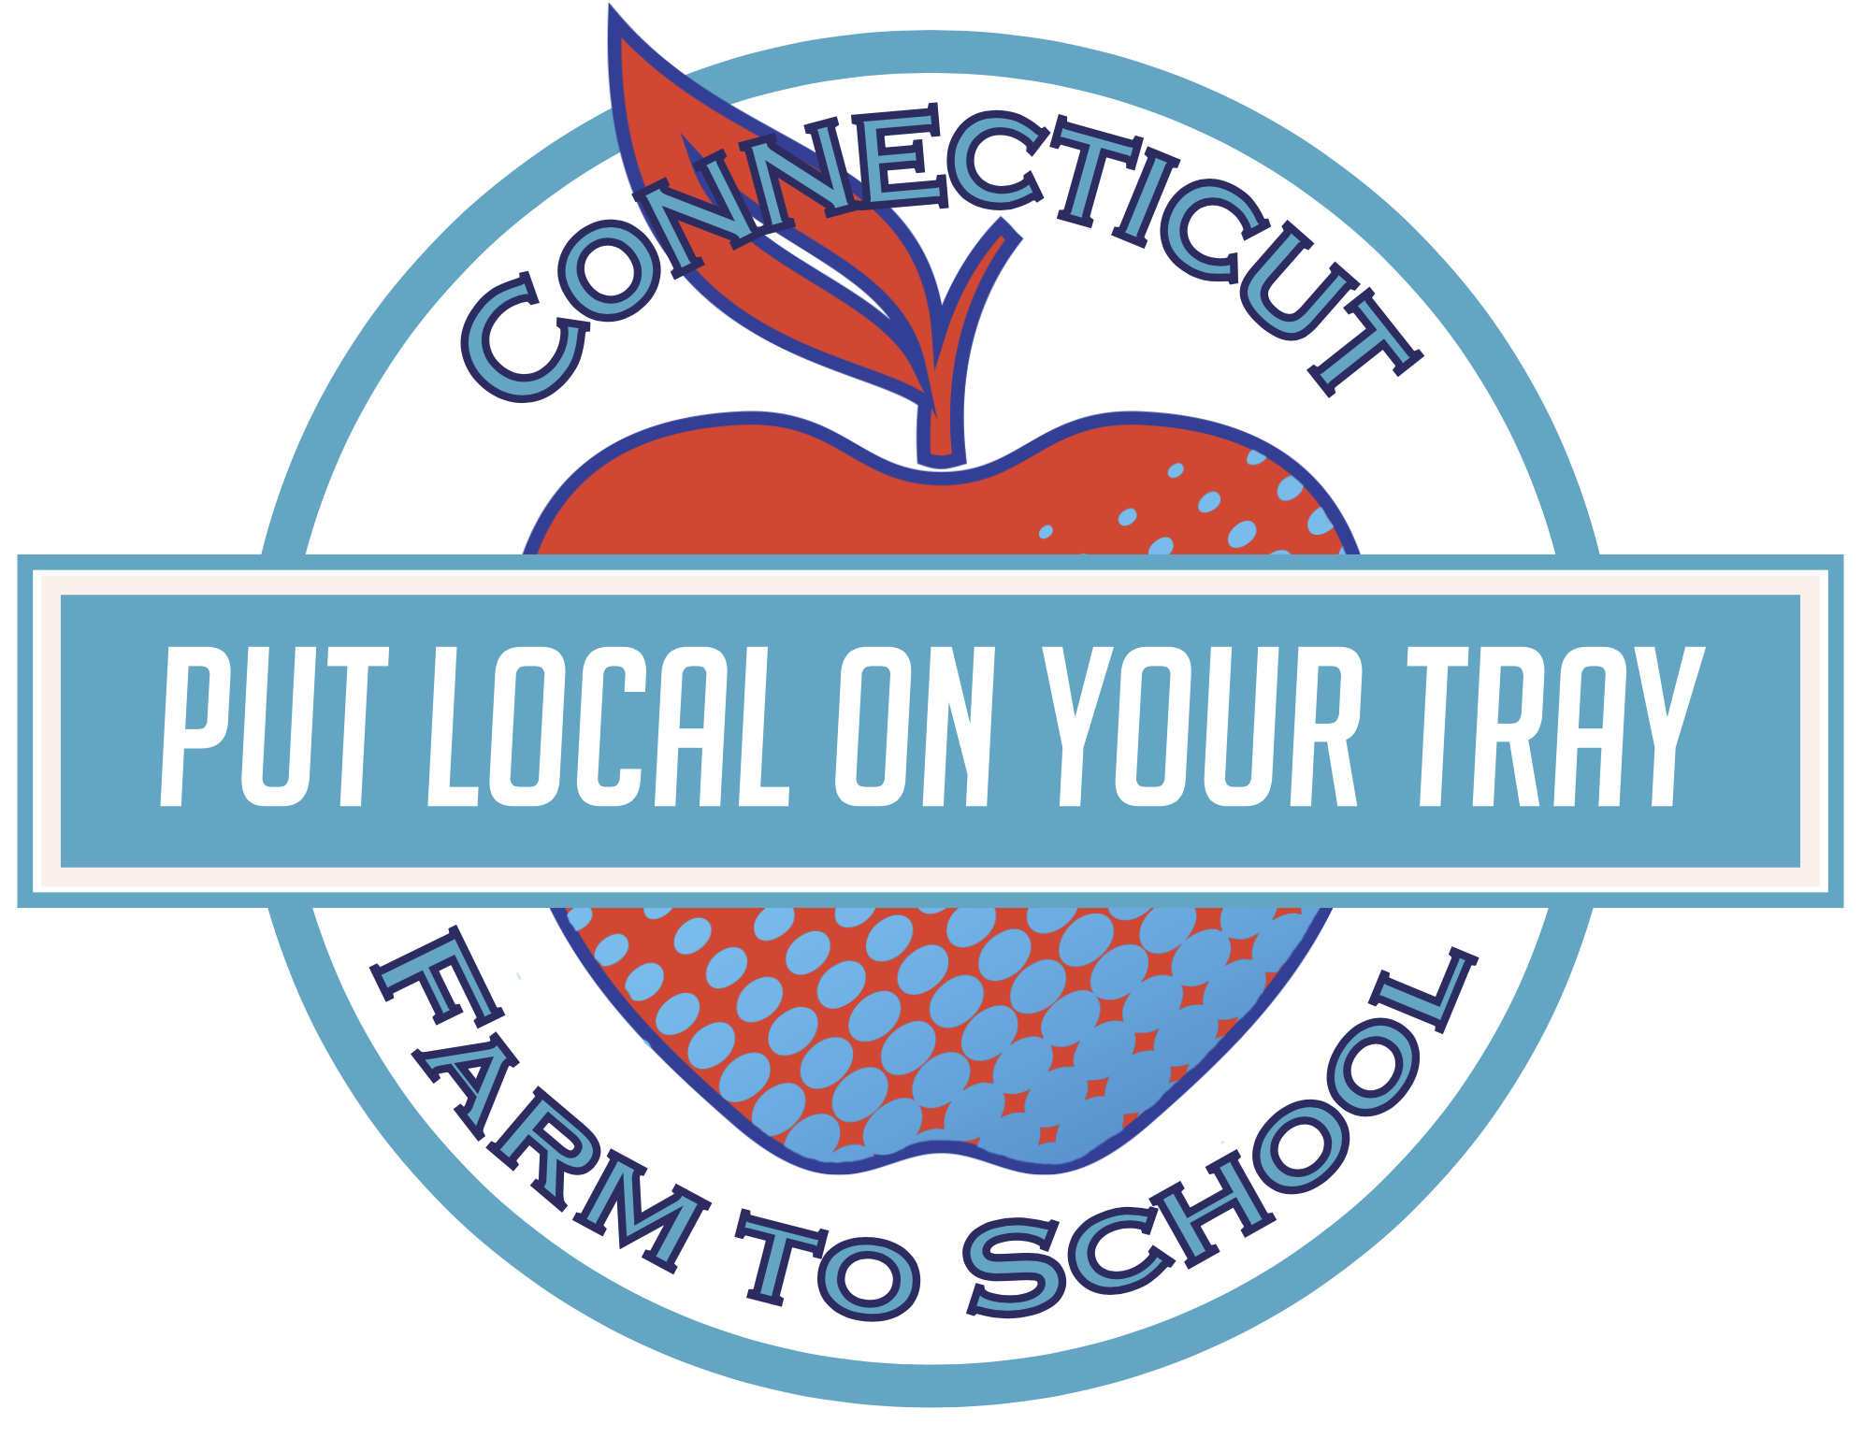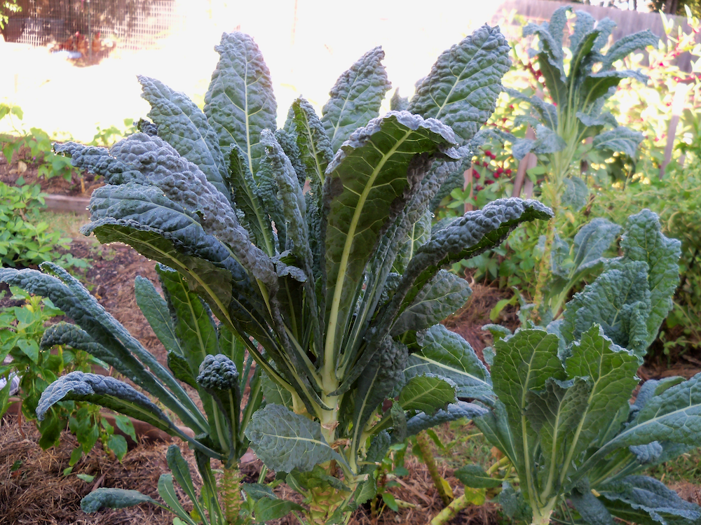

Local Tray Day: Monday, November 16th

Tasty Tidbit #1:

Studies show that kids may need to try a new fruit or vegetable 7 times or more before their palates adjust and a preference develops. Keep calm and taste on!

**Superpowers of Kale:**

Kale is extremely nutritious. It is full of chlorophyll, fiber, iron, vitamins C, K, and A. It even has cancer-fighting compounds!

**Kale is part of the Cabbage Family:**

There are many different kinds of kale: flat-leaf (Lacinato), curly-leaf, and even purple (Red Russian). What kinds are grown at your local farm or store?

**Fun To Know**

This month Spencer Elementary School

is celebrating

This month our cafeteria is featuring local KALE grown in Connecticut. Food Service staff are getting ready to prepare some delicious samples with this fresh produce.

On **Monday, November 16th** students will have a chance to sample local kale chips. We’ll be voting on the dish, and we may see the chips on the lunch menu later in the month! We will be featuring and tasting a different local product each month this year through our Put Local On Your Tray project.

## Get your taste buds ready!

Kale

NOVEMBER

November : 2015

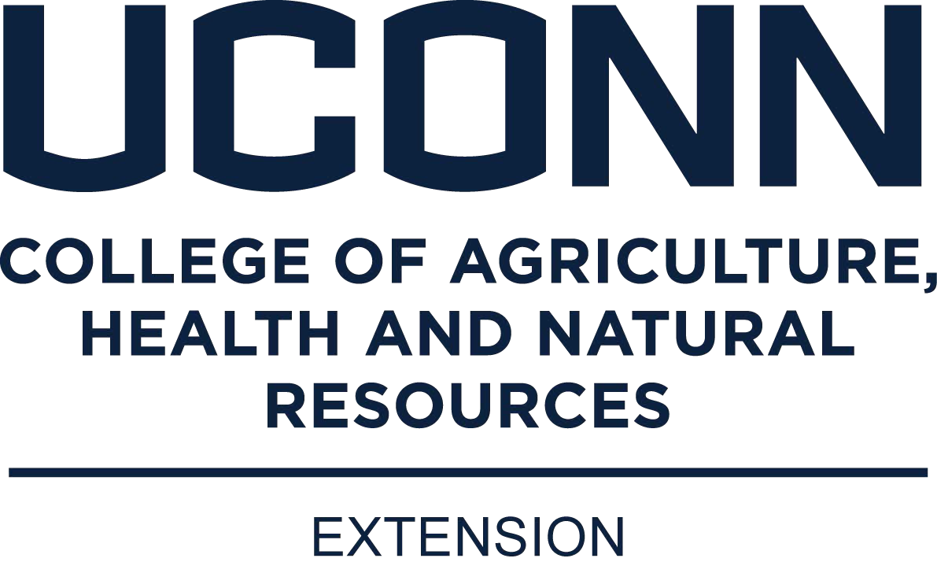

**Kale Chips**

Ingredients: Kale • Olive Oil • Salt • Pepper

Preheat oven to 350° F. Tear leaves into pieces, compost stems.

Wash kale pieces. Spin dry in a salad spinner, then pat dry with a towel.

Place dry kale on a baking sheet and pour a small amount of oil over it.

Gently mix until completely covered with oil. Sprinkle with salt and pepper.

Bake for 10-15 minutes until just crispy. Watch closely! Remove from the oven before they brown.

**Kale Chip Flavor-Bonanza!**

Experiment with the kale chip recipe to the left to create some new flavors.

Would your family like a Latin American mix with cumin and chili powder?

How about an Asian flair with toasted sesame oil and a few drops of soy sauce?

Share your favorite recipes with us on our Facebook page:

www.facebook.com/putlocalonyourtray



### RECIPE

### ACTIVITY

**Find a farm near you, pick up some produce, and have some fun! Not sure where to go? Visit buyctgrown.com to find local products near you.**

Bring it

HOME

**Visit *Put Local On Your Tray* online!**

[**www.putlocalonyourtray.uconn.edu**](http://www.putlocalonyourtray.uconn.edu)

[**www.facebook.com/putlocalonyourtray**](http://www.facebook.com/putlocalonyourtray)