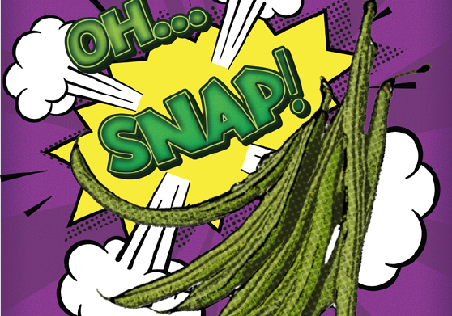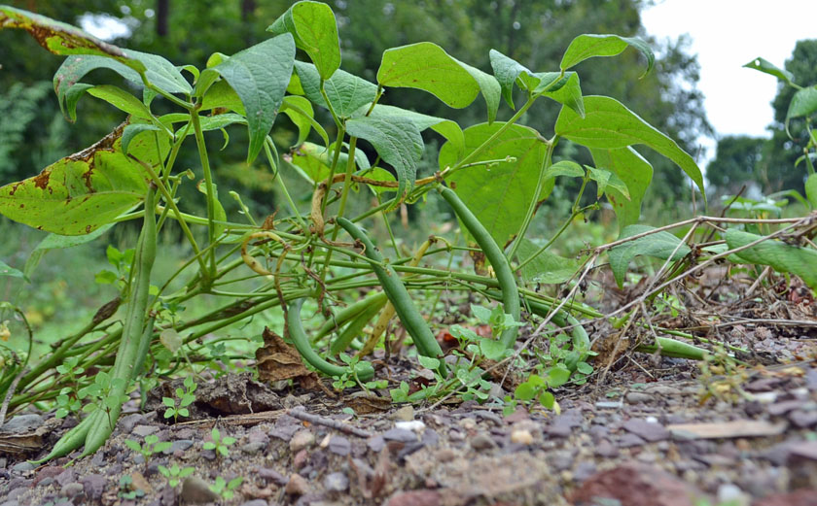 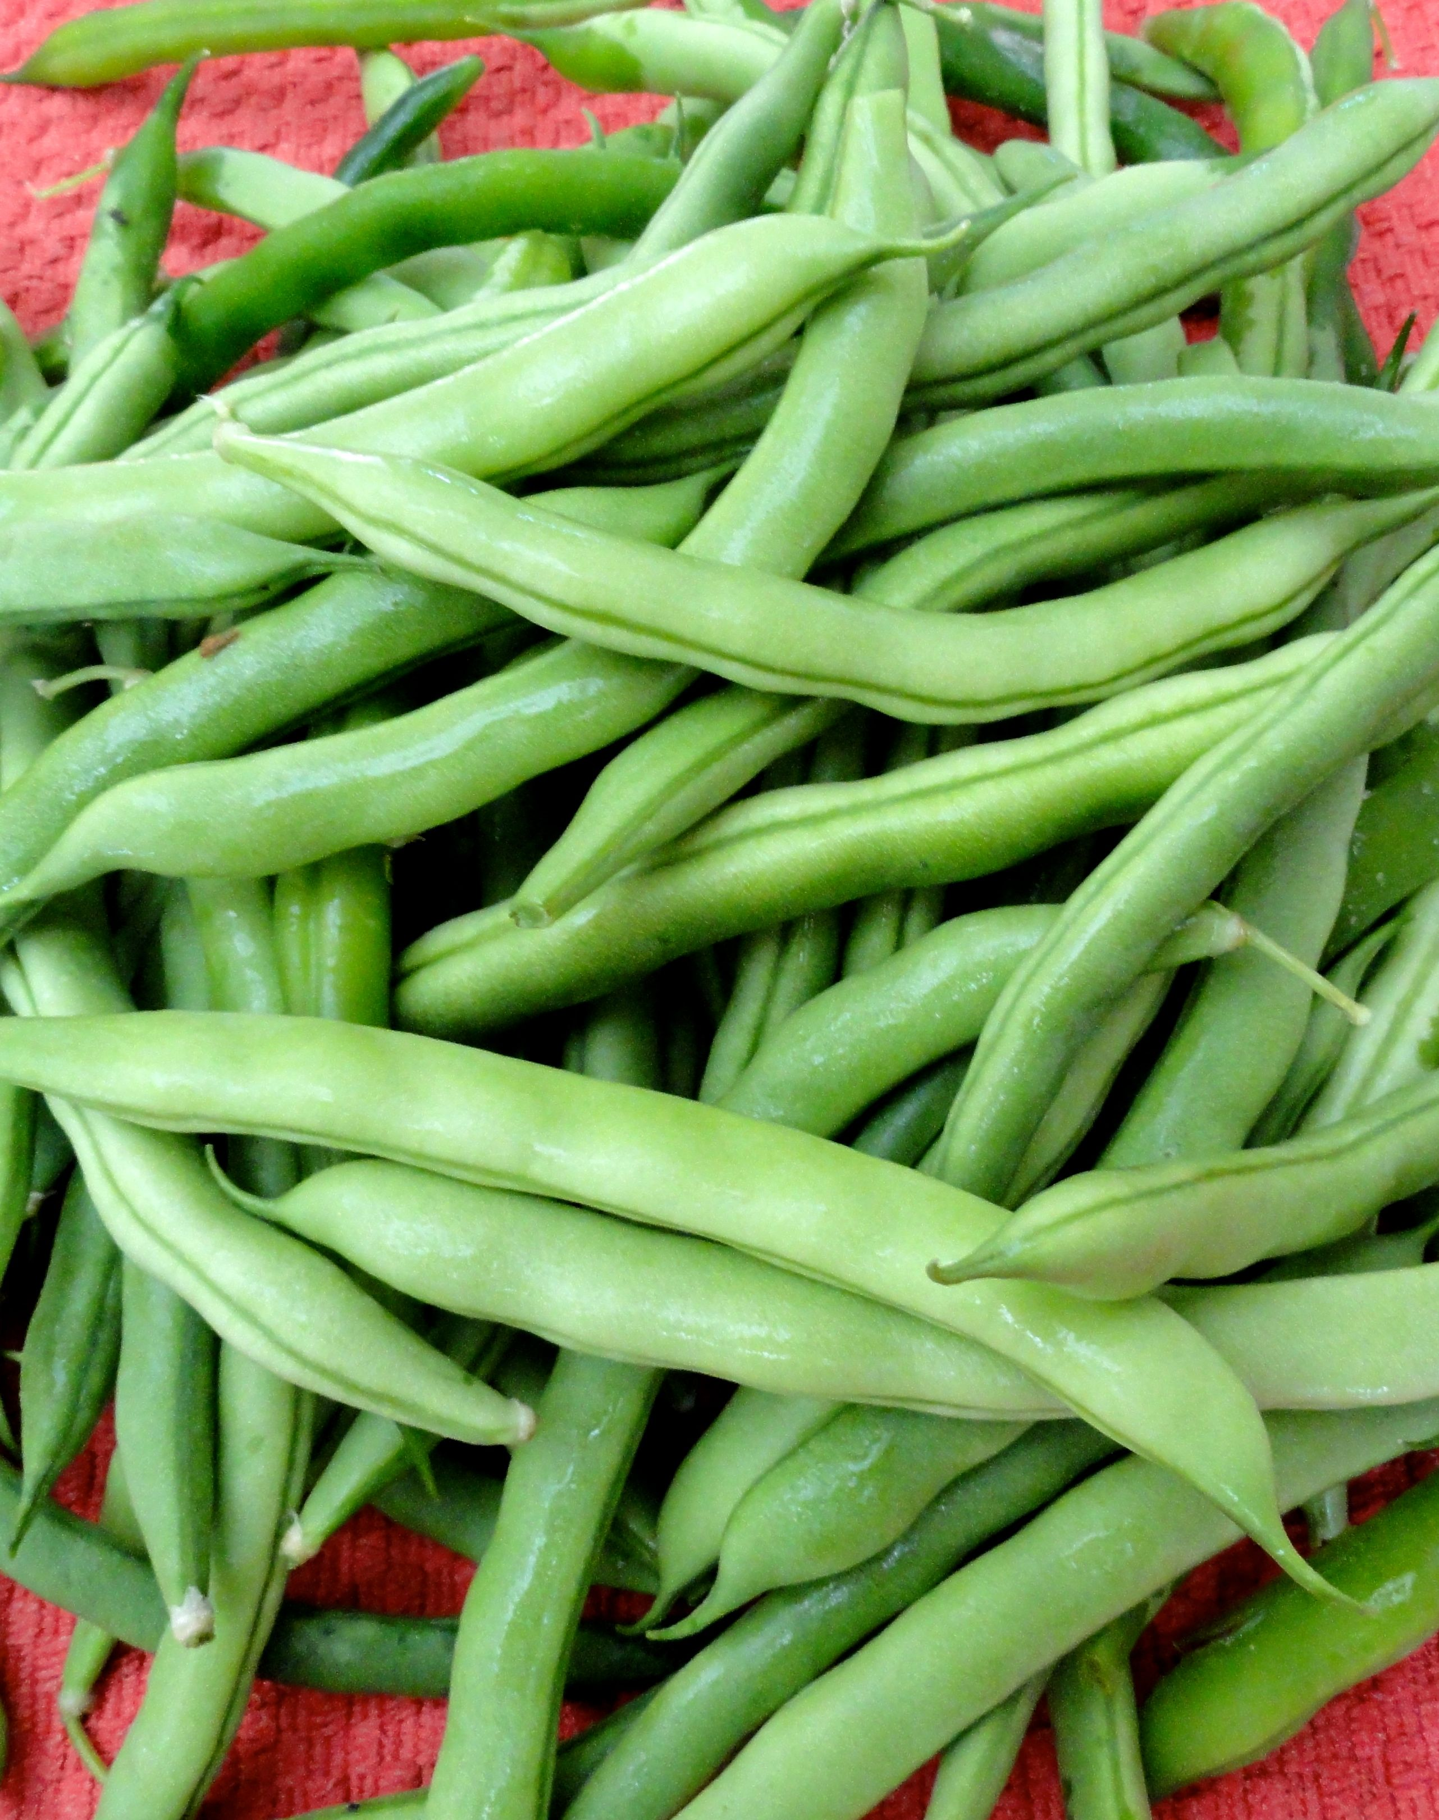

Green

Beans

Insert text here about your taste-test or another event you are using to feature green beans this month

Tasty Tidbit:

You can tell if a green bean is fresh by bending it in half. If you hear a clean snap and the bean breaks, it has been recently picked!

## Get your taste buds ready!

This month **_____Elementary School**

is celebrating local

**Title 2**

Green bean trivia

2

**Fun To Know:**

**Title**

Green bean trivia

LOCAL TRAY DAY

Tuesday, August __

AUGUST

August : 2015



**Green Bean Activity**

?



Separate the seeds and count how many there are. How close did you get?



**Green Bean Recipe**

Ingredients:

**Find a farm near you, pick up some produce, and have some fun! Not sure where to go? Visit buyctgrown.com to find local products close to home.**

### RECIPE

### ACTIVITY

Bring it

HOME

**Visit *Put Local On Your Tray* online!**

[**www.putlocalonyourtray.uconn.edu**](http://www.putlocalonyourtray.uconn.edu)

[**www.facebook.com/putlocalonyourtray**](http://www.facebook.com/putlocalonyourtray)