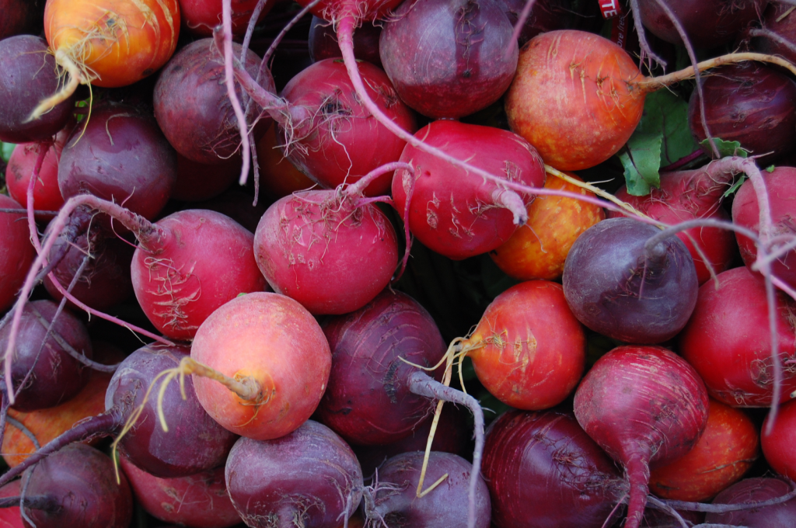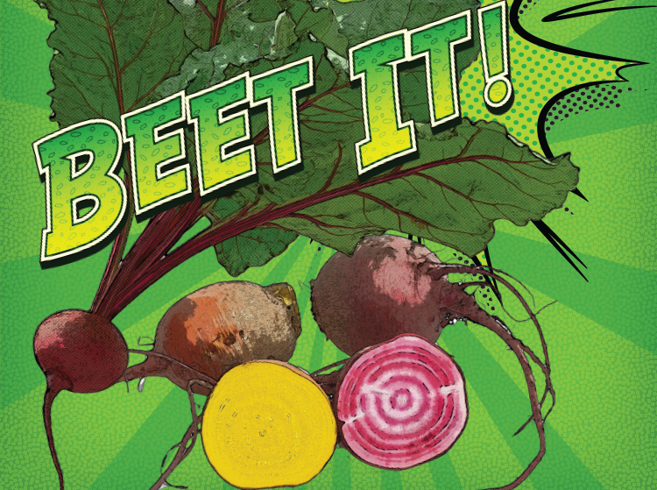 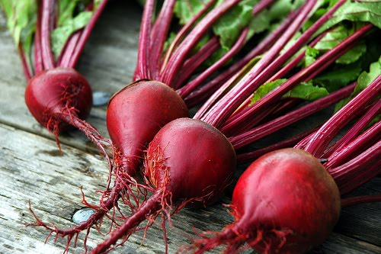

**Sugar Beets**

Because beets are quite sweet, certain varieties are grown for processing into sugar, and there are even kinds that are grown as a sweet snack for livestock!

**Many Colors**

Beets can be red, purple, white, gold, or even red and white candy-striped.

Beets

This month **______**school

is celebrating local with:

This month our cafeteria is featuring local _______ from **________FARM in _____ Connecticut!**

On Tuesday February 15th, students will have a chance to sample ___________ (see next page for the recipe!). They will vote on whether they: Tried It (it wasn’t my favorite), Liked It (it was pretty good), or Loved It (it was delicious!).

Beets are good for your heart because of their iron content. This makes them a perfect vegetable to feature during the month of February during which we celebrate Valentines Day. We love healthy hearts!

Tasty Tidbit:

Beets are a truly nutritious vegetable. You can eat both the roots and the tops raw or cooked!

## BEET the winter blues!

**Fun To Know:**

LOCAL TRAY DAY

Tuesday, February 15th

DECEMBER

February : 2017



**Find a farm near you, pick up some produce, and have some fun! Not sure where to go? Visit buyctgrown.com to find local products close to home.**

**Beet Art**

Add 3 parts beets to 1 part water in a blender and blend until smooth. Strain the juice to get large lumps out. Use as a watercolor paint or add cornstarch to make it thicker.

-or-

Add 3-parts beets to 1-part water in a saucepan. Bring to a boil and simmer for 10 minutes until water has rich beet color. Drain the beets and use the water as a watercolor paint or add cornstarch to thicken.

* Use these paints to decorate cards for family and friends! Thick, light colored paper will work best.
* You can also use the beets like stamps by cutting them in half and carving a design into them.
* Try making other paints with other vegetables, spices, or things found in the kitchen (tea, turmeric, & carrots work well!)



**Visit *Put Local On Your Tray* online!**

[**www.putlocalonyourtray.uconn.edu**](http://www.putlocalonyourtray.uconn.edu)

[**www.facebook.com/putlocalonyourtray**](http://www.facebook.com/putlocalonyourtray)

**Roasted Beet Hummus**

**Ingredients:** 1 small roasted beet, 1 15 oz. can chickpeas (mostly drained), juice of 1 lemon, 1 clove garlic, ¼ cup olive oil, salt & pepper to taste

Scrub your beet until clean, wrap it in foil, drizzle a little bit of oil and roast in the oven at 375 degrees until fork tender.

Cool and peel the beet. Quarter it and place in a food processor. Pulse until the beet is finely chopped.

Add all of the ingredients (except olive oil) and blend until smooth.

Drizzle in olive oil. Mix to combine. Taste and add seasoning as needed.

Enjoy with whole grain crackers, bread or your favorite veggies!

### RECIPE

### ACTIVITY

Bring it

HOME