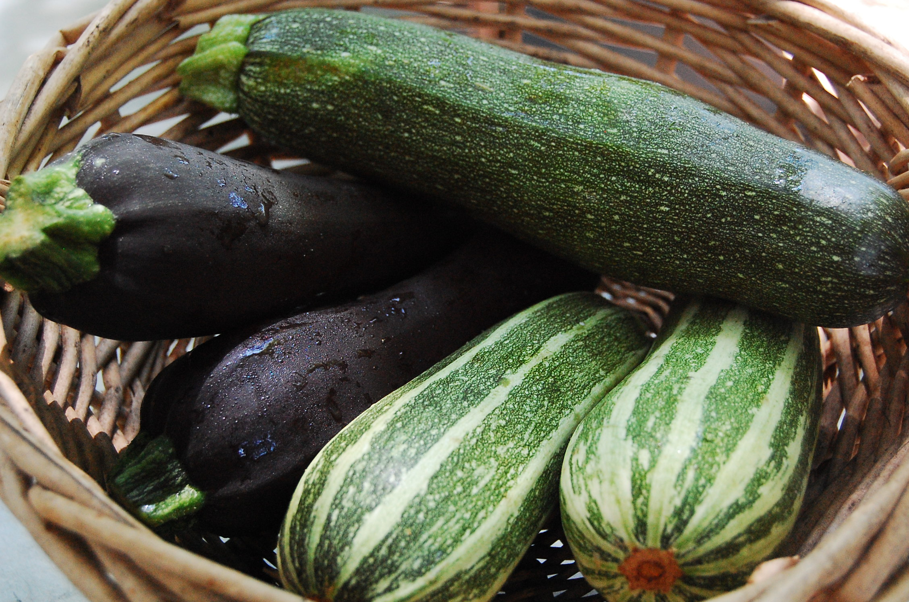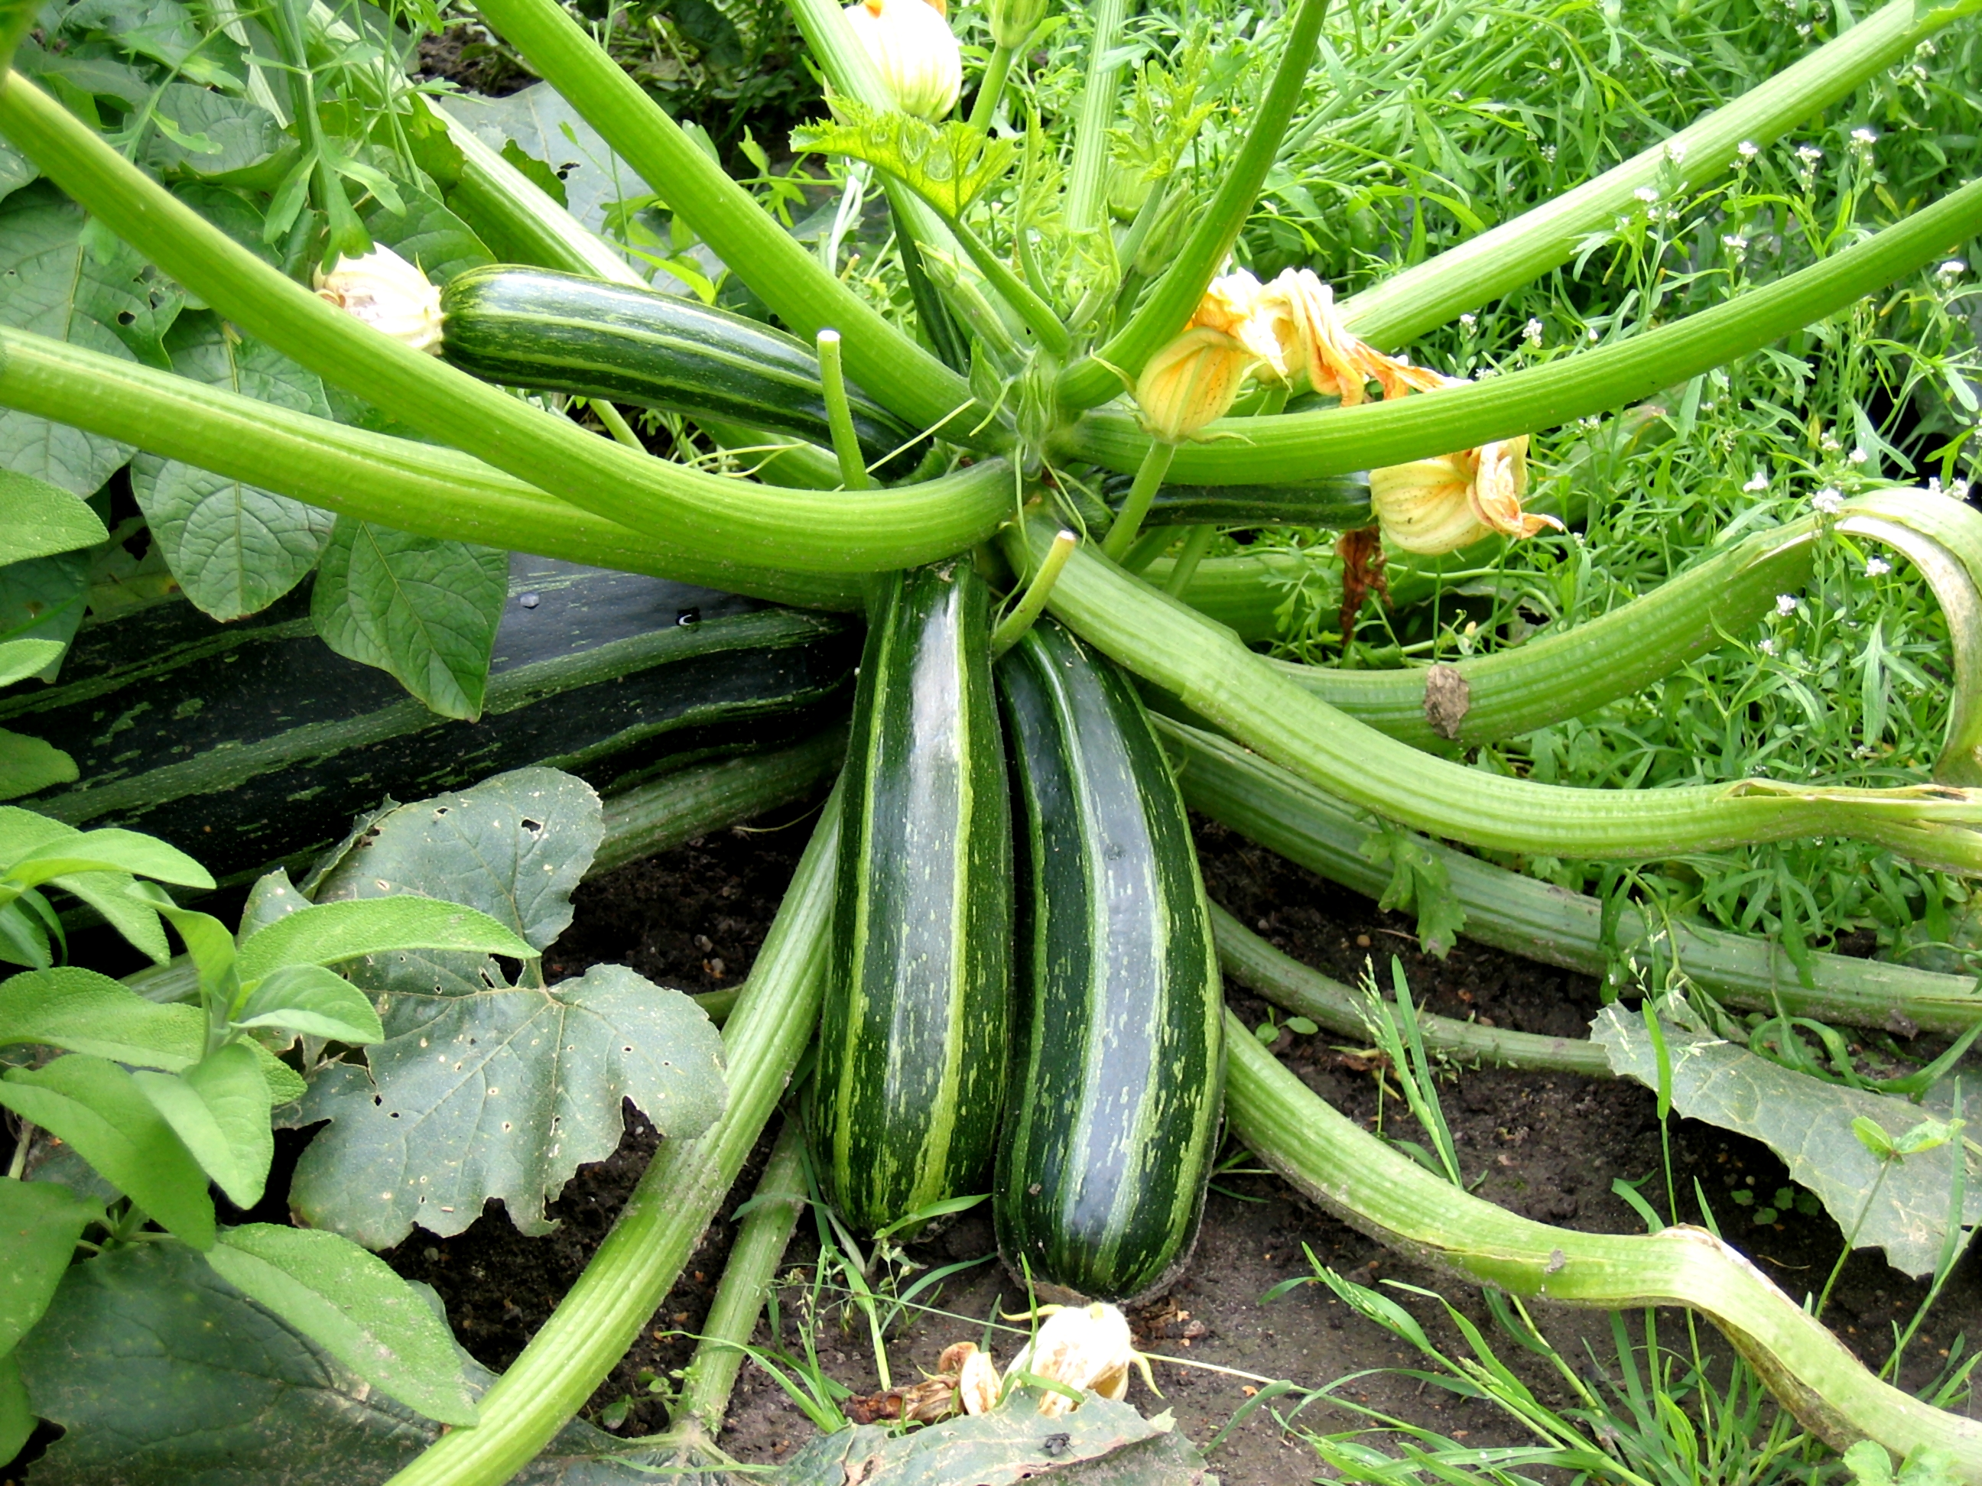

Tasty Tidbit:

Did you know you can eat summer squash and zucchini raw? Slice thinly and dunk in your favorite healthy dip, just like a cucumber or carrot!

This month Anne E. Norris School is celebrating local with:

Summer

Squash!

**Edible Flowers:**

Summer Squash vines grow giant yellow/orange flowers. These are edible and delicious fresh in a salad or fried!

Local Tray Day: Thursday, July 21st

This month East Hartford Summer Meals program is featuring locally grown produce during Local Tray Days at certain sites as a part of the Put Local on Your Tray program!

On **Thursday, July 21st** students eating at the Anne E. Norris school site will have a chance to taste local roasted summer squash from DeFrancesco & Sons farm in Northford, CT. These farmers cultivate 120 acres of vegetables and fruits, and have been doing so for five generations right here in Connecticut!

## Get your taste buds ready!

**Big Guys:**

Zucchini and Summer Squash can grow very large. The largest Zucchini on record was 65 pounds, and 69.5 inches long!

**JULY**

**Fun To Know**

July : 2016



**Stuff It!**

Find the biggest zucchini you can (don’t forget to check at farms or farmstands!)

Boil, steam or microwave it whole until it is tender (stick a fork in it to check), then let it cool and drain.

Scoop out the insides with a spoon

Now come up with a recipe on your own to create the stuffing! Scramble up some eggs sausage and cheese? Sautee some onions and other vegetables? Once you have your stuffing prepared, place it in the space you made in your zucchini. Bake for 15 minutes at 350, or until golden brown. Make sure you record your recipe so you can make it again if you like it!



**Baked Zucchini Chips**

Ingredients: ¼ cup dry breadcrumbs • ¼ cup grated Parmesan diced • ¼ tsp garlic powder • 1/8 tsp pepper • 2 Tbs milk • 2 ½ cups sliced zucchini (1/4 inch thick) •

Preheat oven to 425

Combine first 5 ingredients in a bowl and whisk

Dip zucchini in the mixture.

Place on an oiled wire rack over a baking sheet

Bake for 30 minutes until browned and crispy!

**Find a farm near you, pick up some produce, and have some fun! Not sure where to go? Visit buyctgrown.com.**

### RECIPE

### ACTIVITY

Bring it

HOME

**Visit *Put Local On Your Tray* online!**

[**www.putlocalonyourtray.uconn.edu**](http://www.putlocalonyourtray.uconn.edu)

[**www.facebook.com/putlocalonyourtray**](http://www.facebook.com/putlocalonyourtray)