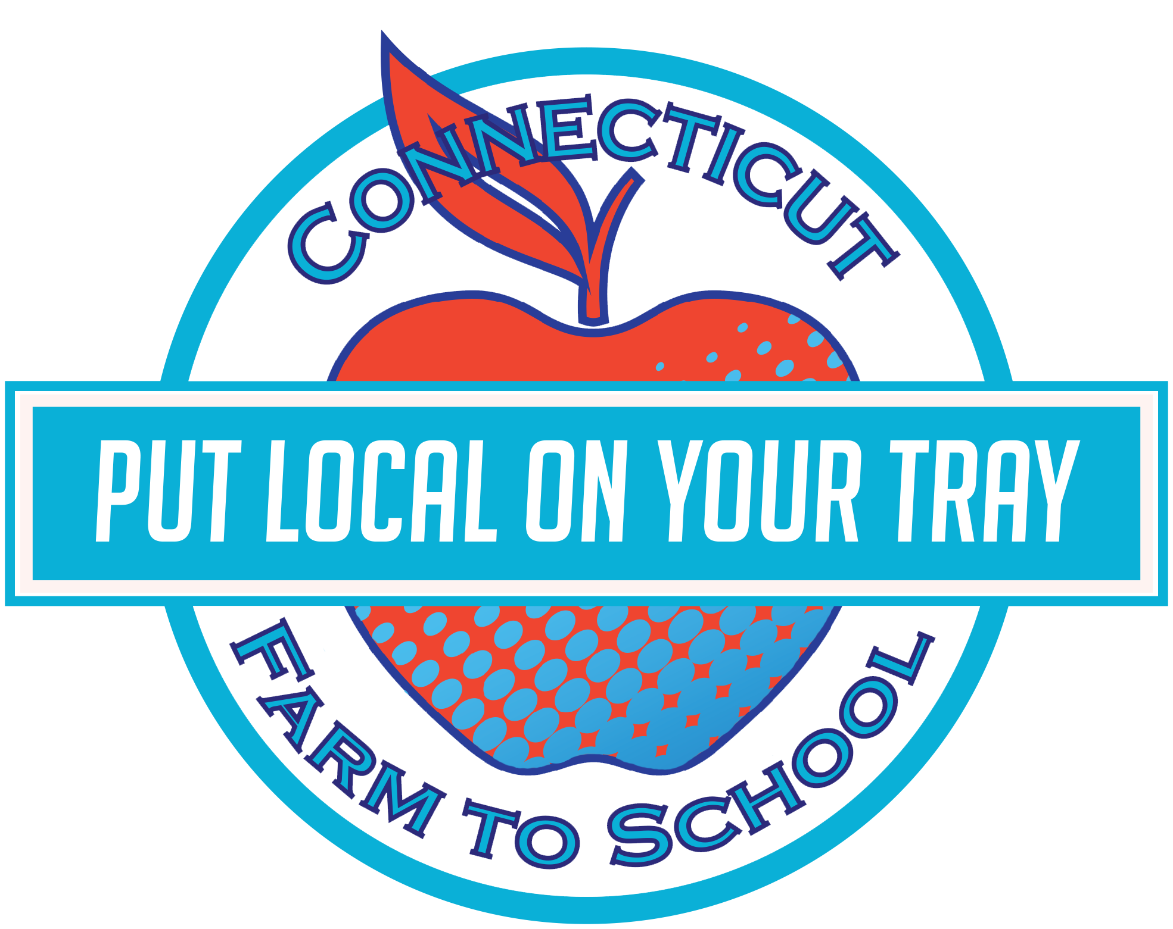 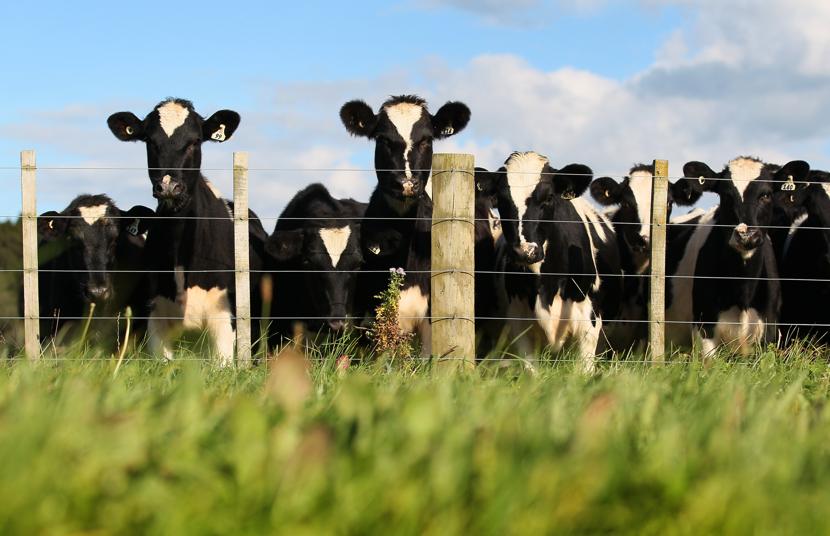

This month **___________ School**

is celebrating local

Dairy

**Fun To Know:**

**Bathtub of Water**

One cow will drink about 30-50 gallons of water *every day*. That’s about a bath-tubs worth!

**Milk Ratios**

It takes more than 21 pounds of whole milk to make 1 pound of butter. It takes 12 pounds of whole milk to make 1 gallon of ice-cream!

Tasty Tidbit:

Yogurt with live active cultures can ease digestion, boost immunity, & help you fight infection. And yogurt gives your body the protein, calcium, and other nutrients that all dairy does!

This month our cafeteria is featuring local dairy! Did you know that most of the milk served in schools comes from our New England dairy farms?

On **Wednesday, December 9th** students will have a chance to sample _____________(see next page for the recipe!). They will vote on whether they: Tried It (it wasn’t my favorite), Liked It (it was pretty good), or Loved It (it was delicious!).

Dairy farmers have

## Get your taste buds ready!

LOCAL TRAY DAY

Wednesday, December 9th

MARCH

March : 2016

 

**Yogurt Parfait**

**Ingredients:**

½ cup of berries (or your favorite fruit!)

½ cup yogurt

½ cup granola

In a cup, place a small layer of yogurt for the base.

Put your fruit on top of this base. Add more yogurt.

Top off with crunch granola and Enjoy!

*Tip:* Using a clear cup will show off all the delicious layers of this snack!

**Marbled Milk Paper**

Cut water color paper to fit inside a casserole dish (or other shallow tray).

Pour 3-4 tablespoons of milk into the tray (or just enough to cover the bottom of the tray).

Add drops of food coloring to the milk then a dd dollops of dish soap around the tray

Using a Q-tip or toothpick, swirl the colors. Take a sheet of your pre-cut paper and lay it on top of the milk mixture. Press down and gently lift.

Let dry completely

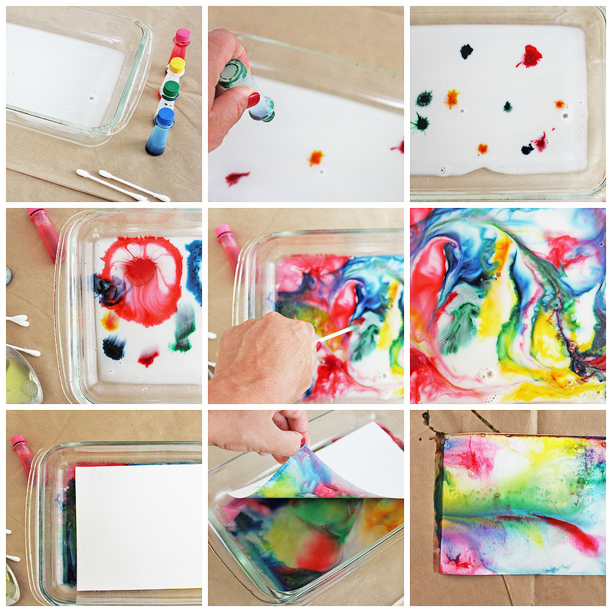



Separate the seeds and count how many there are. How close did you get?



**Find a farm near you, pick up some produce, and have some fun! Not sure where to go? Visit buyctgrown.com to find local products close to home.**

### RECIPE

### ACTIVITY

Bring it

HOME

**Visit *Put Local On Your Tray* online!**

[**www.putlocalonyourtray.uconn.edu**](http://www.putlocalonyourtray.uconn.edu)

[**www.facebook.com/putlocalonyourtray**](http://www.facebook.com/putlocalonyourtray)